Faculty of Computing



[Computer Communications & Network]

Submitted by: Azka Humayon - 47631

Submitted to: Dr. Shumaila Qayyum

Dated: 2/14/2025.

Code:

<!DOCTYPE html>

<html lang="en">

<head>

    <meta charset="UTF-8">

    <meta name="viewport" content="width=device-width, initial-scale=1.0">

    <title>Color Changing Shapes</title>

<style>

canvas {

     border: 1px solid black;

    display: block;

      margin: 20px auto;

        }

body {

font-family: Arial, sans-serif;

 text-align: center;

margin-top: 50px;

 }

.button-container {

     margin-bottom: 20px;

        }

    button {

     padding: 10px 20px;

    margin: 5px;

    font-size: 16px;

        }

    </style>

</head>

<body>

    <canvas id="myCanvas" width="400" height="400"></canvas>

    <p>Select what you want to draw</p>

    <div class="button-container">

     <button onclick="drawRectangle()">Draw a Rectangle</button>

    <button onclick="drawCircle()">Draw a Circle</button>

    </div>

    <p>Select color to fill your drawing</p>

    <div class="button-container">

     <button onclick="changeColor('red')">Red</button>

    <button onclick="changeColor('blue')">Blue</button>

      <button onclick="changeColor('black')">Black</button>

    </div>

    <script>

    const canvas = document.getElementById('myCanvas');

    const ctx = canvas.getContext('2d');

    let currentColor = 'blue';

    let currentShape = 'rectangle';

    function drawRectangle() {

    ctx.clearRect(0, 0, canvas.width, canvas.height);

     ctx.fillStyle = currentColor;

    ctx.fillRect(50, 50, 150, 100);

     currentShape = 'rectangle';

    }

    function drawCircle() {

    ctx.clearRect(0, 0, canvas.width, canvas.height);

    ctx.beginPath();

      ctx.arc(200, 200, 50, 0, Math.PI \* 2);

    ctx.fillStyle = currentColor;

     ctx.fill();

    ctx.stroke();

    currentShape = 'circle';

    }

    function changeColor(color) {

    currentColor = color;

    if (currentShape === 'rectangle') {

     drawRectangle();

    } else {

   drawCircle();

        }

    }

    drawRectangle();

    </script>

</body>

</html>

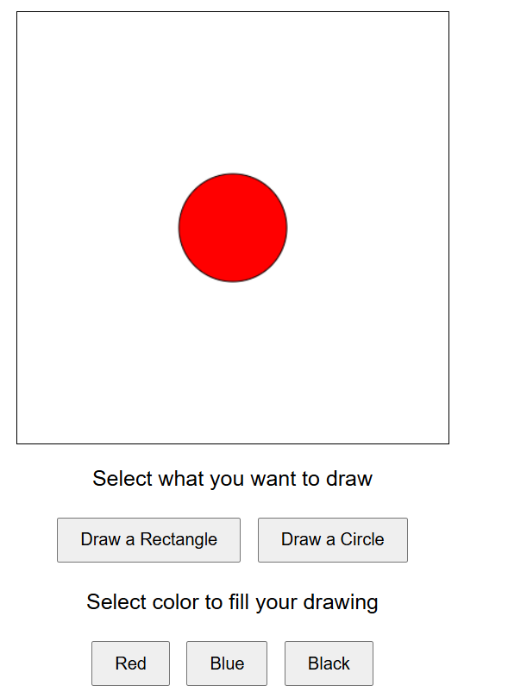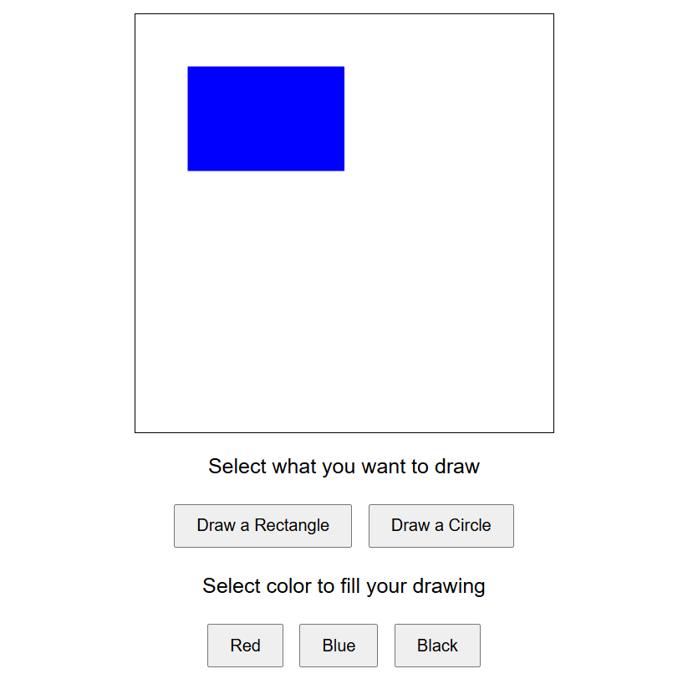Outputs: